**Biology 313**

**Discussion 8, week of 10-30-2017**

**20 pts**

**1.** Shown below are the responses of neuron A in response to action potentials fired by neuron B:

neuron A

neuron B

time

**a)**.(1pt) Draw out this circuit showing which cell is presynaptic and which is postsynaptic

**B is presynaptic, A is postsynaptic.**

**b).** (3pts)Why do the psps in neuron A increase in amplitude with each new stimulus from neuron B?

**The buildup of Ca++ in the terminal allows for increasingly large amounts of nt to be released with each AP. The last AP is far enough from the previous AP’s where the Ca++ is allowed to diffuse out of the terminal and does not lead to a large psp.**

**c).** (1pt) why is the response at point reduced from the response that preceded it?

**As mentioned above, the Ca++ in the synapse has had time to diffuse away from the terminal unlike previous AP’s that happened in a short period of time.**

d) (1pt) How do you know that this effect is not due to spatial or temporal summation?

**Can’t be temporal, multiple AP’s fired in a short period of time should create epsp’s of same strength in the postsynaptic cell. In this case, the strength of the EPSP increases with each AP. Simultaneous inputs should also be only a fixed size AP, so it is likely not summation either.**

**2.** Shown here are the effects of stimulating the *syrup* and *butter* neurons on the activity of the *pancake* neuron in the brain of the breakfastfish.

response of mV

*pancake* neuron 0 mV

time time

single stimulus to *butter* neuron single stimulus to *syrup* neuron

mV *pancake* neuron’s response to a

0 single stimulus first to *syrup* followed

by a single stimulus to *butter* neuron

time

**a)** (3pts) Draw out a circuit for these neurons- who synapses with whom

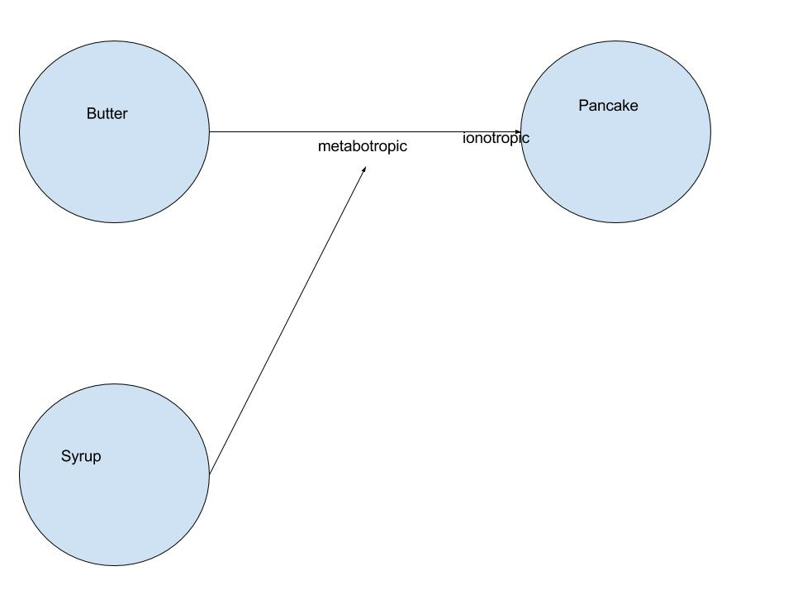

**Butter directly synapses with pancake, syrup synapses with the butter**

**b)** (2pts) Do the synapses in this circuit use a neurotransmitter-mediated ionotropic receptor or neuromodulator-mediated metabotropic receptor? Label them on your drawing

**Syrup is metatrophic to butter, butter is ionotrophic to pancake**

**c)** (5pts) Now is time to explain how the stimulation of syrup before stimulation of butter produces the smaller psp in the pancake neuron:

(1) What could be happening to the amount of neurotransmitter received by the pancake neuron?

**It is probably reduced.**

(2) Describe how this could occur, in terms of what channels are affected.

**The syrup neuromodulators can make the butter neuron’s Ca++ channel harder to open.**

**3.** (4pts) There are a number of mutations that have been identified in fruit flies as well as in humans that affect learning. For each of the following, state, which next step in the learning pathway is disrupted, and whether this would increase or decrease learning.

**a)** Flies with a mutation in the *amnesiac* gene lack activator of adenyl cyclase

**Deficent in adenylyl cyclase -> cannot inc cAMP. Not enough to strengthen synapses.**

**b)** Flies with a mutation in the *turnip* gene (I am NOT making up these names!) have less effective G-proteins

**Metabotrophic signals/ pathways will be less effective or less potent.**

**c)** transgenic flies have been created that enhance expression of CREB 1

**CREB1 joins cAMP to bind DNA, Activate transcription factor(s)**

**\* which promote transcription of genes**

**1. for enhancing transmitter release.**

**2. prehaps making more synapses/receptors**

**This fly may be able to learn better.**

**d)** a temperature sensitive mutation causes the overexpression of CREB 2 when experimenters increase temperature on the fly

**Creb2 is a transcription repressor, Should do the opposite of above CREB1, learning repressor**

LANGs – Crows

Cooperative breeding

-Where non reporducing suboordinate helpers assist in raising offspring of others, forgo chance to breed on their own to help others